A MULTI-ANALYTICAL STUDY OF BRAZILIAN COMMERCIAL ACRYLIC PAINT OF ARTISTIC USE

Marcelo Miyada REDÍGOLO^{1,}*, Marcos Vinícius Rodrigues ALVES¹,
Isolda COSTA², Oscar Vega BUSTILLOS¹

¹ Instituto de Pesquisas Energéticas e Nucleares – Centro de Química e Meio Ambiente (CQMA), Av Prof Lineu Prestes, 2242 – Cidade Universitária, São Paulo – SP, Brazil, 05508-000
² Instituto de Pesquisas Energéticas e Nucleares – Centro de Ciência e Tecnologia dos Materiais (CCTM), Av Prof Lineu Prestes, 2242 – Cidade Universitária, São Paulo – SP, Brazil, 05508-000

Abstract

Contemporary Brazilian artists worked massively with paints made in Brazil. Conservation of acrylic paints is an issue and has been studied for the past two decades. European and North American paints were studied in detail, but there is scarce information on paints produced in other countries. Therefore, it is vital to characterize Brazilian artist paint and better understand their ageing process, outlining proper conservation methodologies then. Complementary analytical techniques were employed to characterize the paint samples, namely pyrolysis gas chromatography-mass spectrometry (Py-GC/MS), Fourier transform infrared (FTIR) and Raman spectroscopies and scanning electron microscopy-energy dispersive X-ray spectroscopy (SEM-EDS). Results indicate that Brazilian acrylic blue paints (phthalocyanine and Prussian) are composed of polystyrene (PS) copolymers, in contrast to imported paints, mainly composed of poly(metyhl methacrylate) (PMMA) copolymers.

Keywords: FTIR; Py-GC/MS; SEM-EDS; Raman; Contemporary art; Phthalocyanine blue; Prussian blue

Introduction

The social revolution caused by the popularization of synthetic polymer-based products have also influenced the arts. Since 1930, acrylic emulsion and alkyd paints have been progressively incorporated into the artist’s palette [1]. Somewhat, acrylics were protagonists of Abstract and Contemporary Art. The use of these, as opposed to oil, also meant a break from tradition for many artists.
For the past twenty years, studies have been conducted on how to properly conserve acrylic painted canvases [2, 3], as they are more prone to attract dirt and require specific cleaning processes, different from oil paintings.
Brazilian contemporary artists, such as Maurício Nogueira Lima, Hermelindo Fiaminghi, Geraldo de Barros, Mira Schendel and Lygia Clark [4], have used acrylic paints extensively. According to art historians and artists’ testimonies, Brazilian painters favored national-made paint over high-price imported products during the most prolific period of their career. Materials retrieved from artists’ studios, such as Ivan Serpa, Maurício Nogueira Lima and Tomie Ohtake, confirm their preference for Brazilian paints [5]. This long-lasting cost problem is illustrated in the 1954 colorless strike led by artists Djanira da Motta e Silva, Iberê Camargo and Milton DaCosta. More than 600 artists engaged in this movement, painting solely in black and white to protest high import taxes for artist paint, which although being oil paints were still very costly. Heretofore, imported (USA, GBR, ITA, NLD) paints are almost ten times more expensive than Brazilian paints.
Studies have been conducted on acrylic paints manufactured in the USA [6], Mexico [7] and Denmark [8], but not in countries with sparse tradition in artist paint making. Chemical characterization is vital information for conservators, given the case of Donald Judd's Hi-Fi Purple, where the artist himself adverted the wrong use of purple paint to restore his artwork [9] and in cleaning processes, as pointed out by Lomax et al. [10] and Doménech-Carbó et. al. [11].
This paper presents the characterization of acrylic blue paints manufactured by two Brazilian companies, Acrilex and Corfix. Results were compared with two reputed imported brands available in Brazil, Liquitex and Winsor & Newton. Analyses were carried out by pyrolysis gas chromatography-mass spectrometry (Py-GC/MS), Fourier transform infrared spectroscopy (FTIR), Raman spectroscopy and scanning electron microscopy coupled with energy dispersive x-ray fluorescence spectrometry (SEM-EDS) techniques.

Experimental

Materials
Brazil has only two manufacturers of artist paint, Acrilex and Corfix. Paints were selected based on commercial availability, that is, same color in different brands. Three phthalocyanine blue (Bpc) and three of Prussian blue (Bpr) paints were used (Table 1). Corfix company has released a professional grade paint (Corfix Arts) in 2017. Samples were prepared applying paint on microscope glass slides.

Table 1. Chemical characterization by Py-GC/MS, FTIR, Raman and SEM-EDS,
indicating paint origin, color, medium and elemental analysis.

Sample | Origin | Color | Medium | Elements
Acrilex | BRA | BPc | PS | Al, Si, S, Cu, Ti
Corfix | BRA | BPc | PS | Si, S, Cu, Ti
Corfix Arts | BRA | BPc | P(S/MA) | Al, Si, S, Ca, Cu, Ti, Ce
Liquitex | USA | BPc | P(nBA/MMA) | Al, S, Ca, Cu
Acrilex | BRA | BPr | PS | Na, Mg, Al, Si, S, Ca, Fe
Corfix | BRA | BPr | PS | Na, Al, Si, S, Cu
Corfix Arts | BRA | BPr | P(S/MA) | Na, Al, Si, S, Fe, Ti, Ce
Winsor & Newton | GBR | BPr | P(S/MMA) | Na, Al, Si, S, K, Ca, Fe

Methods
The analytical techniques selected to conduct this investigation are based on the suitability for characterizing art materials. Therefore, the instrument parameters must meet conservation standards regarding sampling, where minimum or no samples should be taken from artworks. Py-GC/MS offers broad insight on chemical composition, as the sample components are fully identified based on their molecular mass after being separated by chromatography. A rapid differentiation of medium acrylic polymer is provided by FTIR technique, based on the identification of organic functions of the monomer main chain. Raman spectroscopy was also employed as a complimentary technique to FTIR. The aforementioned techniques do not provide conclusive information on inorganic pigments or fillers. For that reason, SEM-EDS was used to evaluate pigment and filler presence on each sample. Microscopy not only indicates the distribution of pigments but also their particle size, while EDS provides qualitative elemental analysis.
Py-GC/MS
The instrument used was a PY-3030D microfurnace pyrolyzer (Frontier Lab) mounted over a Shimadzu Co. GCMS-QP5000 equipped with SGE BPX5 column 5% phenyl polysilphenylene-siloxane (30m x 0.25µm x 0.25mm). Pyrolysis was performed at 610°C for 0.20min with Py-GC interface at 300°C and GC-MS interface at 280°C. The GC oven temperature was 40°C (held for 2min.) with a 10°C·min⁻¹ rate and final temperature of 350°C (2 min). The MS split was 1:150 and the m/z was scanned from 40 to 600µm in electron impact ionization mode (EI+, 70eV). Spectra were compared to NIST library standards and the works of Tsuge et al. [12] and Tom Learner [1].
FTIR
Infrared spectra were collected on a Varian 660IR model coupled with a VeeMax II reflectance accessory (Pike Technologies), from 4000 to 400cm⁻¹ and for 100 scans with a resolution of 1cm⁻¹, reflectance angle at 51°. Kubelka-Munk (K-M) function was used.
Raman
The spectrometer used was a Cora Family 5500 (Anton Parr) equipped with 785nm excitation laser, covering the 100 to 2300cm⁻¹ range with resolution of 12cm⁻¹ and laser power of 450mW. Vibrational spectra, FTIR and Raman, were compared with IRUG (Infrared and Raman Users Group) database.
SEM-EDS
Microscopical analyses were performed on a TM3000 (Hitachi Co.) scanning electron microscope coupled with a Quantax70 energy dispersive X-ray fluorescence spectrometer (Bruker Nano GmbH). Images and elemental analyses were obtained at 15kV and working distance 5.1mm.

Results and discussion

Acrylic paints are a complex formulation that includes numerous ingredients. The final product must meet commercial (shelf life, material costs, environmental and health safety) and artistic (durability, color and film stability, drying rate) demands. Therefore, the paint tube might contain the acrylic binder, pigment or dye, wetting and dispersing agents, thickeners, biocides and defoamers [13].
FTIR and Raman spectroscopies were used to identify binding media, SEM-EDS was used to identify inorganic pigments and fillers, Py-GC/MS was used to identify minor binders and plasticizers. Results are presented in Table 1.
Binding media
Brazilian paints present styrene (S) as the major component. Differently, the binding media of imported paints, namely from USA and Great Britain, is a copolymer of metyhl methacrylate (MMA). Nevertheless, the newly released professional grade Brazilian paint (Corfix Arts) presents poly(styrene-co-methacrylate), P(S/MA), as binding media.
The use of MMA as binding media yields a paint film which is stable, resistant to hydrolysis and transparent to UV. In general, substitution of methacrylate copolymers for polystyrene is due to cost issues [2].
Monomers of each paint sample are identified by infrared and Raman spectroscopies. Figures 1 and 2 show, respectively, FTIR spectra of phthalo blue (BPc) and Prussian blue (BPr) samples. Styrene presence is characterized by infrared peaks at 3087-3018 cm⁻¹ for aromatic C-H stretching (ν), 1428cm⁻¹ for ring breathing and 1612cm⁻¹ for C=C stretching. Raman spectra for Corfix and Corfix Arts paints are presented in figure 3. Characteristic peaks 1076cm⁻¹ for aromatic ring stretching and 1686cm⁻¹ for aromatic νC-H are observed. The presence of MA in Corfix Arts sample is indicated by infrared peaks 1742cm⁻¹ (νC=O), 1229cm⁻¹ (νC-O) and 1427cm⁻¹ (νCH₃) and Raman peaks 1096cm⁻¹ (νC-O-C) and 1686cm⁻¹ (νC=O).

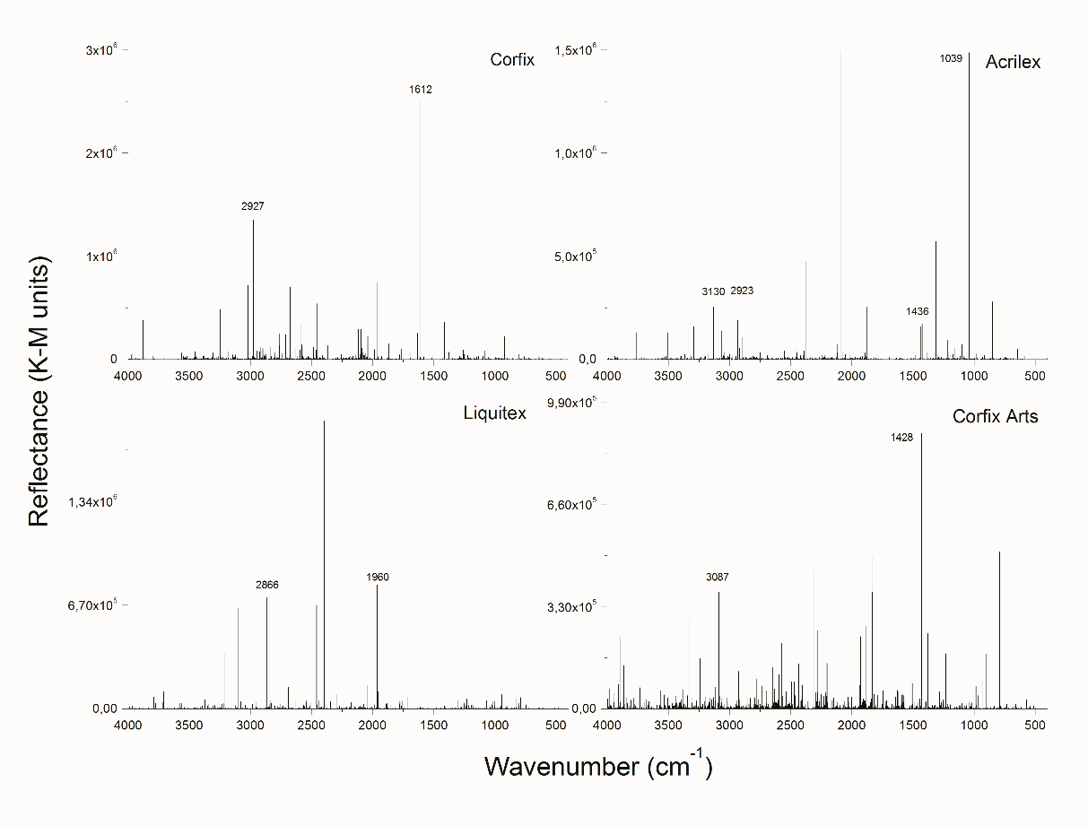
Fig. 1. FTIR spectra of phthalo blue (BPc) paints: Acrilex, Corfix, Corfix Arts (BRA) and Liquitex (USA)

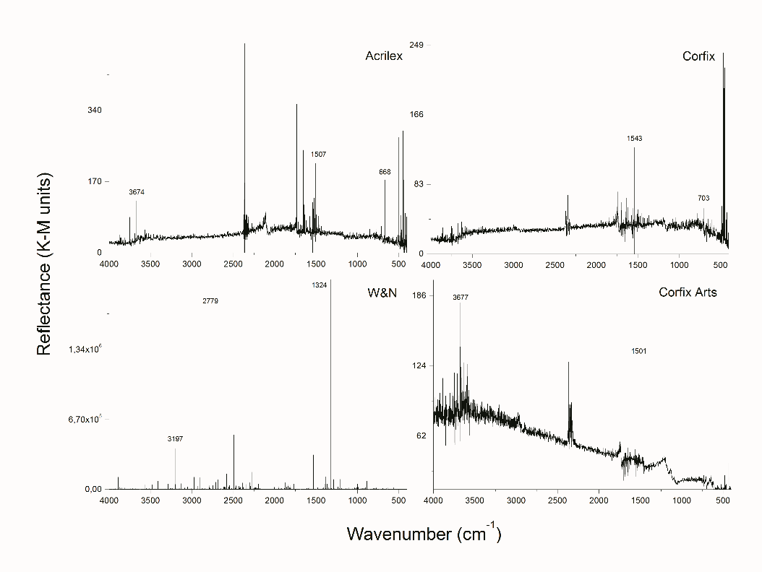
Fig. 2. FTIR spectra of Prussian blue (BPr) paints: Acrilex, Corfix, Corfix Arts (BRA) and Winsor & Newton (GBR)
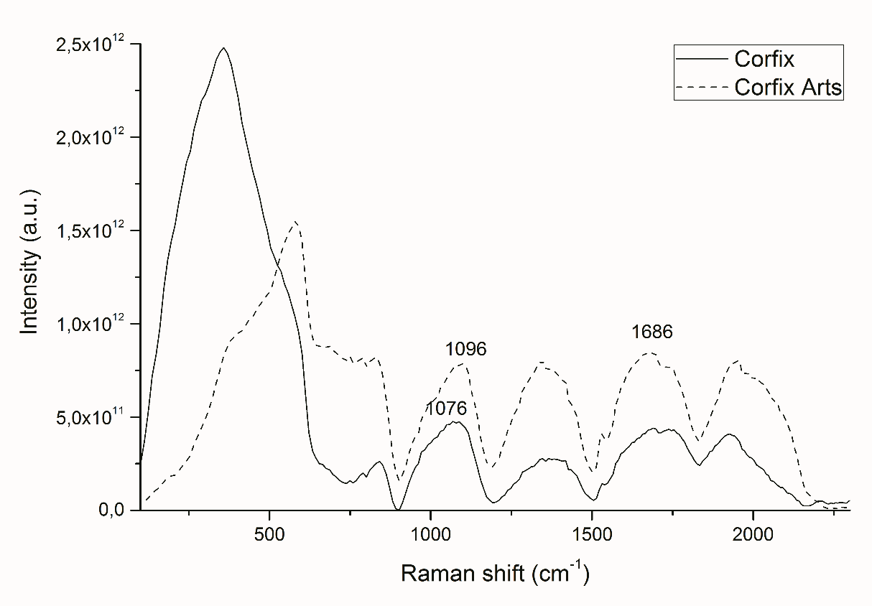
Fig. 3. Raman spectra of phthalo blue (BPc) Corfix and Corfix Arts (BRA)

The binding media present in phthalo acrylic paints are confirmed by Py-GC/MS technique. Figures 4 and 5 present the chromatogram of phthalo blue (BPc) and Prussian blue (BPr) samples. Peaks for PS are indicated by presence of styrene (S), alpha-methylstyrene (αS), styrene dimer (SS and D2) and trimer (SSS). Peaks for P(S/MA) are confirmed by methacrylate (M), styrene (S), a hybrid dimer (SM’) and trimer (SSM and SMS). Chromatogram of P(S/MMA) differs mainly for the MMA monomer identification at 5 min in Winsor & Newton BPr sample. Characteristic peaks of P(nBA/MMA) sample are described elsewhere [1].

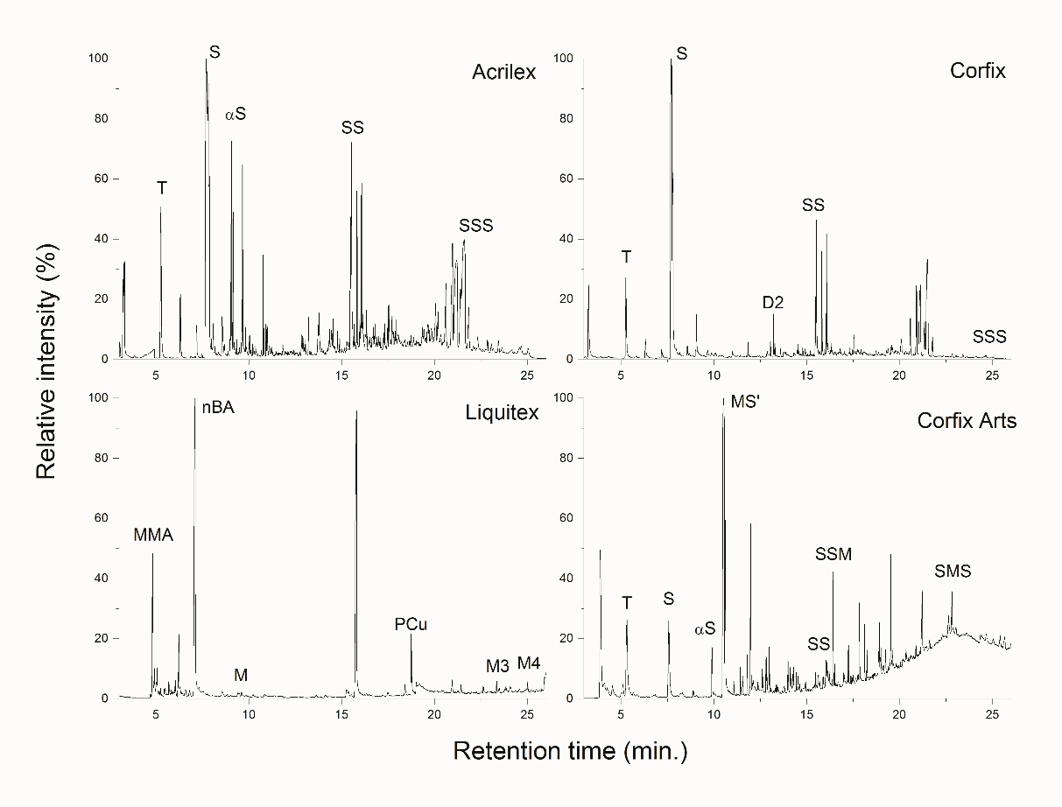
Fig. 4. Py-GC/MS spectra of phthalo blue (BPc) paints: Acrilex, Corfix, Corfix Arts (BRA) and Liquitex (USA)

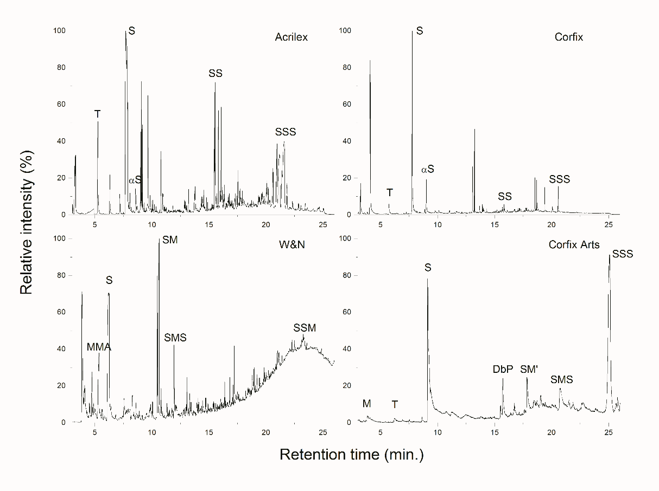
Fig. 5. Py-GC/MS spectra of Prussian blue (BPr) paints: Acrilex, Corfix, Corfix Arts (BRA)
and Winsor & Newton (GBR)

Pigments and extenders
Figures 6 and 7 present SEM images (micrographs) of BPc and BPr samples, respectively. Results indicate that Corfix Arts is the only to resemble the composition of imported materials. Images of samples Acrilex and Corfix, for both paints, BPc and BPr, present lower ratio of particles either pigments or extenders.

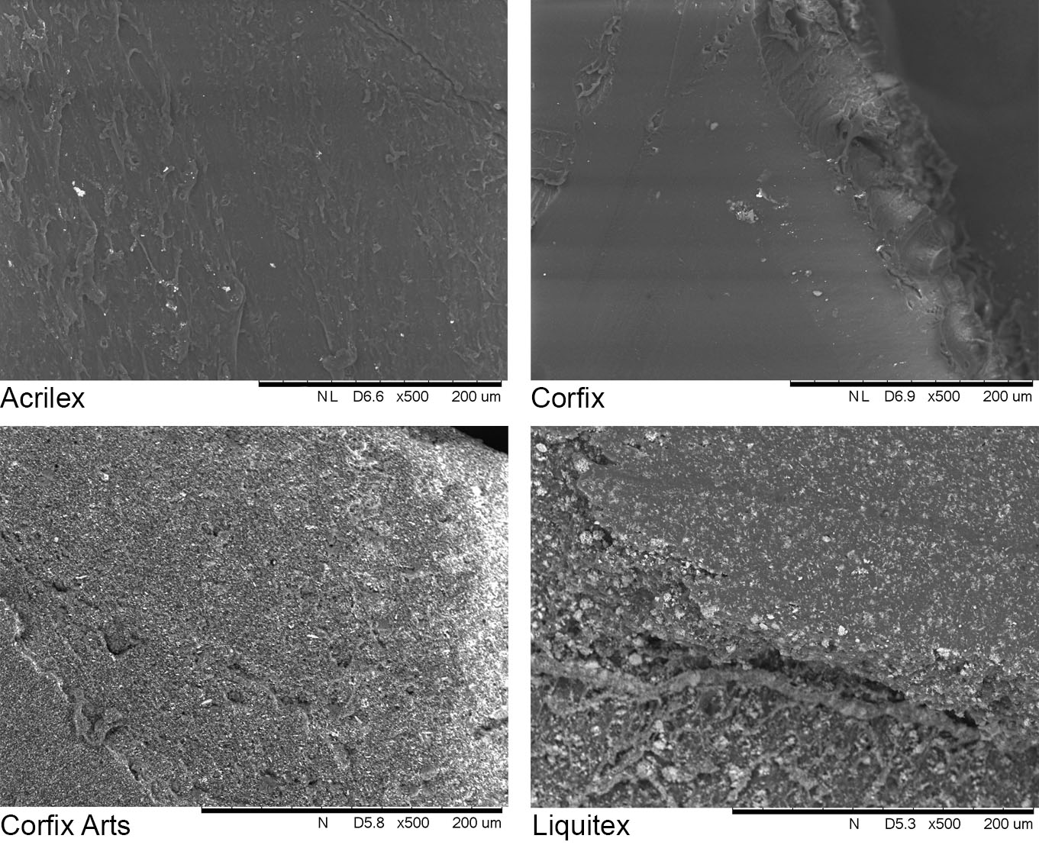
Fig. 6. Micrographs (200µm) of phthalo blue (BPc) paints:
Acrilex, Corfix, Corfix Arts (BRA) and Liquitex (USA)

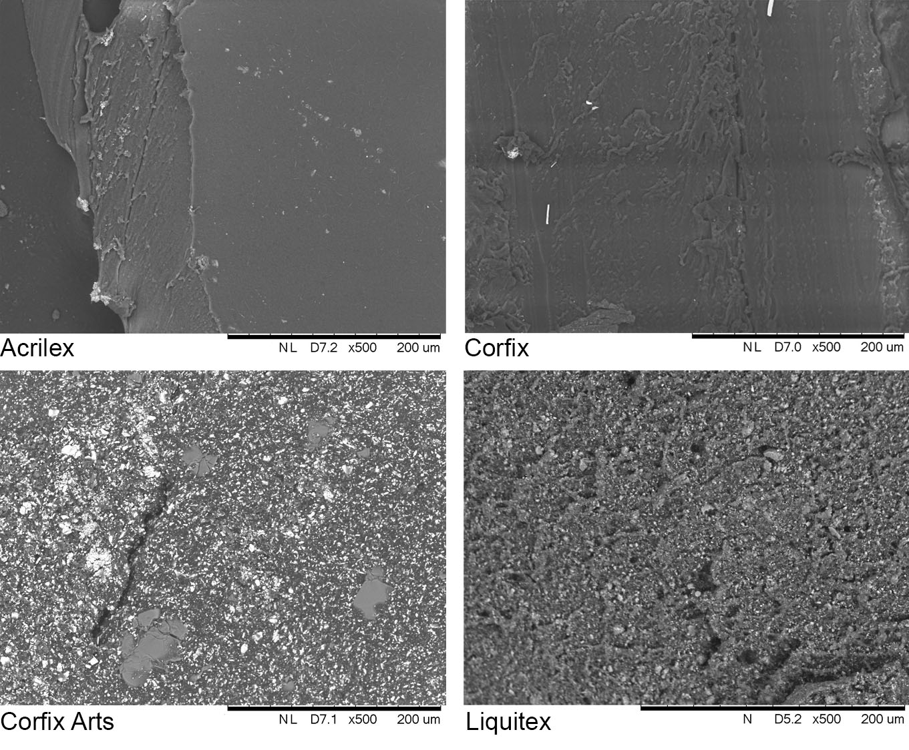
Fig. 7. Micrographs (200µm) of Prussian blue (BPr) paints:
Acrilex, Corfix, Corfix Arts (BRA) and Winsor & Newton (GBR)

Phthalocyanine blue (C₃₂H₁₆CuN₈) is indicated by EDS (Table 1) by presence of copper in all four BPc samples. Prussian blue (C₁₈Fe₇N₁₈) is detected in BPr samples Acrilex, Corfix Arts and Winsor & Newton. Sample Corfix of Prussian blue is composed of copper. Phthalocyanine blue pigment is also detected by Py-GC/MS in Liquitex sample (Fig. 4).
EDS elemental analysis (Table 1, Figs. 8 and 9) indicate that all samples present kaolinite (Al₂Si₂O₅(OH)₄) as filler, except for sample Bpr Acrilex, which contains talc (Mg₃Si₄O₁₀(OH)₂). FTIR analyses indicate the presence of these fillers with peaks at 1039cm⁻¹ (νSi-O), 3750-3500cm⁻¹ (νO-H) and 789-754cm⁻¹ (νAl-Si-O).

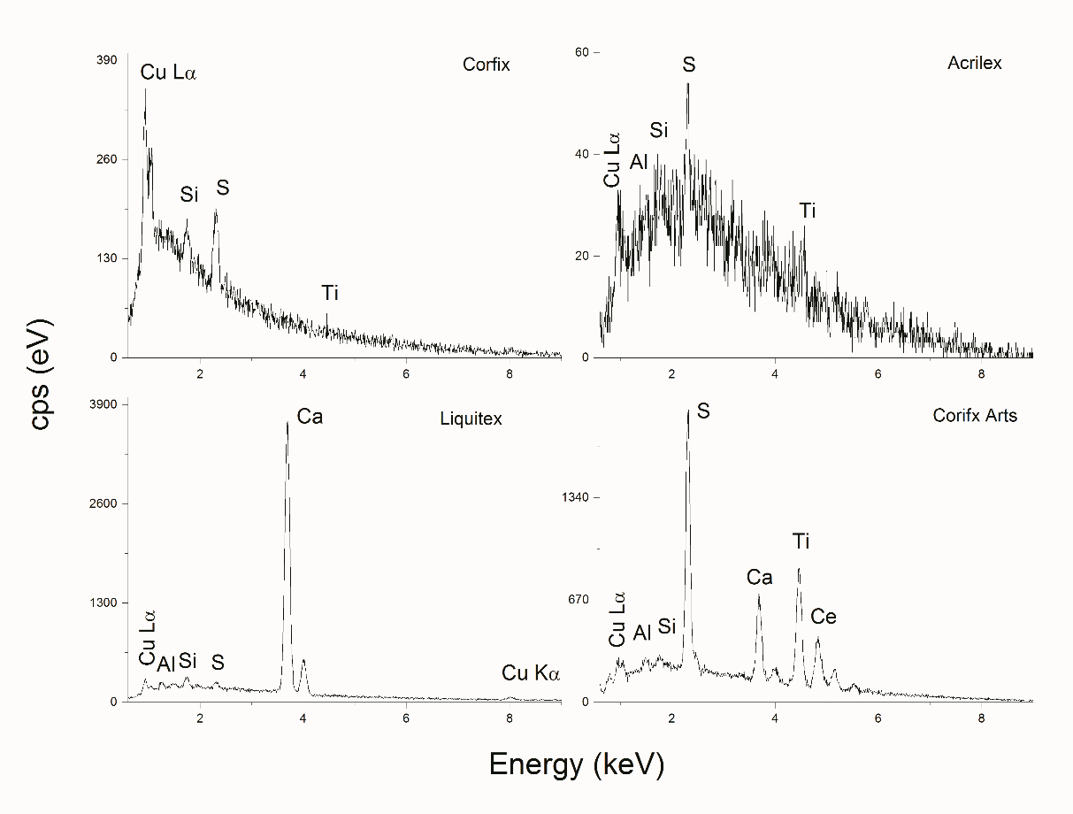
Fig. 8. EDS spectra of phthalo blue (BPc) paints: Acrilex, Corfix, Corfix Arts (BRA) and Liquitex (USA)

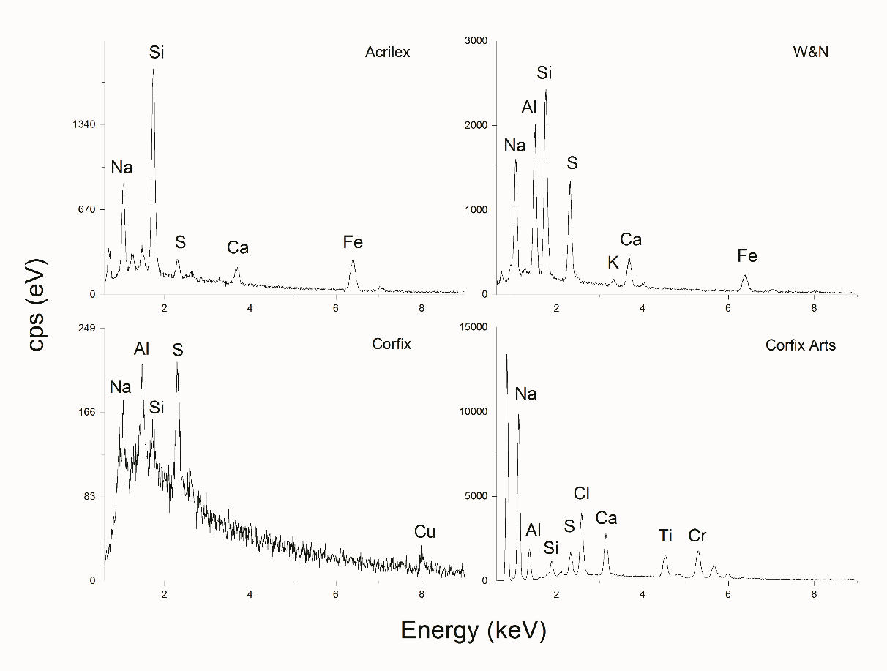
Fig. 9. EDS spectra of Prussian blue (BPr) paints: Acrilex, Corfix, Corfix Arts (BRA) and Winsor & Newton (GBR)

Corfix Arts samples of both BPc and BPr paint present TiO₂ and cerium (Ce). Titanium dioxide is often used to moderate hue and saturation. Rare earth metals, especially Ce, are known to enhance paint properties such as light fastness, chemical resistance and drying time [14].

Conclusions

Chemical composition of artist paints commercialized in Brazil varies greatly. Therefore, a multi-component characterization requires multi-technique analyses. Advantages of each technique (FTIR, Raman, Py-GC/MS and SEM-EDS) were pointed out to present a broader knowledge of the paints used by Brazilian contemporary artists.
FTIR and Raman are, complimentary, able to rapidly identify the main binders, while Py-GC/MS provides further information of copolymers, even in minor concentration levels. SEM-EDS successfully identifies pigments and extenders.
Brazilian paints of student grade are composed of PS binding media and low pigment ratio, whereas the professional grade paint is composed of P(S/MA) binding media, higher pigment ratio and extenders such as TiO₂ and Ce.
Conservation concerns over the ageing processes of these paints will be addressed in future studies.
In conclusion, this initial study provides conservators, artists and conservation scientists information on the composition of artist paints manufactured in Brazil.

Acknowledgments

The authors are grateful to the CNPq National Council of Scientific and Technologic Development for supporting this project, to the Center for Lasers and Applications' Multiuser Facility at IPEN-CNEN/SP and to Anton Paar Brasil for the use of the Raman spectrometer. We also thank Teodora Camargo and Tatiana Russo from the Núcleo de Conservação e Restauro in Pinacoteca do Estado de São Paulo for the invaluable advices.

References

[1] T.J.S. Learner, Analysis of Modern Paints, The Getty Conservation Institute, 2004, p. 236
[2] N. L. Engel, S. Zumbühl, An evaluation of selected retouching media for acrylic emulsion paint, Journal of the American Institute of Conservation, 54, 2015, pp. 224-237.
[3] E. Jablonski, T.J.S. Learner, J. Hayes, M. Golden, Conservation concerns for acrylic emulsion paints, Studies in Conservation, 48, 2003, pp. 3-12.
[4] G. Giovani, L.A.C. Souza, Y. Froner, A. Rosado, The use of industrial paint on wood by Lygia Clark, Studies in Conservation, 61:2, 2016, pp. 291-293.
[5] J.H.R. Barbosa, O uso de materiais pictóricos industriais pelos artistas nas décadas de 1950 e 1960, PhD Thesis, Universidade Federal de Minas Gerais, 2017 p. 312.
[6] C.E. Rogge, B.A. Eppley, Behind the Bocour label: Identification of pigments and binders in historic Bocour oil and acrylic paints, Journal of the American Institute of Conservation, 56, 2017, pp. 15-42.
[7] A. Mejía-González, S. Zetina, M. Espinosa-Pesqueira, N. Esturau-Escofet, Characterization of commercial artists' acrylic paints and the influence of UV light on ageing, International Journal of Polymer Analysis and Characterizatoin, 22, 2017, pp. 473-482.
[8] M. Christiansen, E. Baadsgaard, J. Sanyova, K. Simonsen, The artists' material of P.S. Krøyer: An analytical study of the artist's paintings and tube colours by Raman, SEM-EDS and HPLC, Heritage Science, 5, 2017, pp. 39-50.
[9] N. Khandekar, E. Nagy, J. Miller, P. Gottschaller, C. Mancusi-Ungaro, The re-restoration of Donald Judd's ‘Untitled, 1965’, Modern Paints Uncovered (Editors: T.J.S. Learner, P. Smithen, J.W. Krueger, M.R. Schilling), First edition, Getty Publications, Los Angeles, 2007, pp. 157-164.
[10] S. Lomax, S. Fisher, An investigation of the removability of naturally aged synthetic picture varnishes, Journal of the American Institute of Conservation, 29, 1990, pp. 181-191.
[11] M.T. Doménech-Carbó, M.F. Silva, E. Aura-Castro, A. Doménech-Carbó, L. Fuster-López, J.V. Gimeno-Adelantado, S.U. Kröner, M.L. Martínez-Bazán, X. Más-Barberá, M.F. Mecklenburg, L. Osete-Cortina, D.J. Yusá-Marco, Multitechnique approach to evaluate cleaning treatments for acrylic and polyvinyl acetate paints, in: New insights into the cleaning of paintings (editors: M.F. Mecklenburg, A.E. Charola, R.J. Koestler), Smithsonian Institution Scholarly Press, 2013, pp. 125-134.
[12] S. Tsuge, H. Othani, C. Watanabe, Pyrolysis - GC/MS Data Book of Synthetic Polymers, First edition, Elsevier, 2011, p. 420.
[13] J. Hayes, M. Golden, G.D. Smith, From formulation to finished product: Causes and potential cures for conservation concerns in acrylic emulsion paints, Modern Paints Uncovered (Editors: T.J.S. Learner, P. Smithen, J.W. Krueger, M.R. Schilling), First edition), The Getty Conservation Institute, Los Angeles, 2007, pp. 58-65.
[14] V.R. Sastri, Applications, Modern Aspects of Rare Earths and Their Complexes (Editors: V.R. Sastri, J.C. Bünzli, V. Ramachandra Rao, G.V.S. Rayudu, J.R. Perumareddi), First edition, Elsevier, 2003, pp. 893-981.
______________________________________

Received: Octomber 02, 2018
Accepted: August 24, 2019

* Corresponding author: marcelo.redigolo@usp.br

